Blue cloth Helmets of An Garda Siochána na hÉireann.
By Austin G. Fennessy
This article intends to give some clarity to the evolution of the helmets worn by the Gardaí since the formation of the Irish state in 1922 and continuing until the 1950’s.
Only a few variations in helmet were in use, all blue cloth types. The types included both Day and Night helmets.
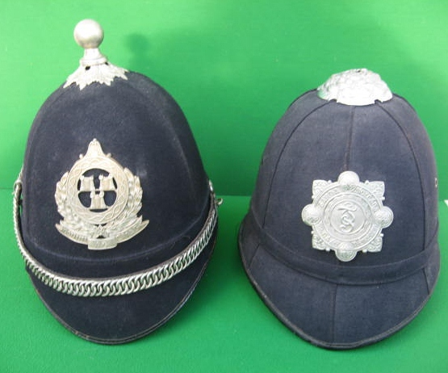
Above:- left this is a four panelled 1922 -25 era Poiliní Átha Cliath helmet. By 1925, the Garda helmet plate replaced the Poiliní plate on the same helmet. Above right is the rose topped 1940’s six panel helmet with 7cms X 7cms Garda helmet plate. The Garda motorbike helmet plate was also worn on this six panel style helmet.
The first Garda helmet was a four panelled blue cloth, cork helmet, identical in style to the home service other ranks pattern helmet worn by enlisted ranks in the British army. In collector terminology such helmets are generally referred to as the four panel, ball top Garda helmet. These same four panelled helmets were worn by the Dublin Metropolitan Police (D.M.P.) during the post 1916 Rebellion era. In effect such D.M.P. helmets were only re-badged in 1922. In Dublin at this stage in Irish history, the D.M.P. helmet plate badge was replaced by the Póiliní Átha Cliath helmet plate. In the decade before and after Irish Independence the four panelled style of helmet remained exactly the same, simply the badge was switched.
By 1925, the Póiliní Átha Cliath came under the jurisdiction of An Garda Siochána and once again badges were removed and the 7cms X 7 Garda helmet plate now replaced the Póiliní helmet plate. At this stage the four panelled blue cloth ball top helmet continued in use.
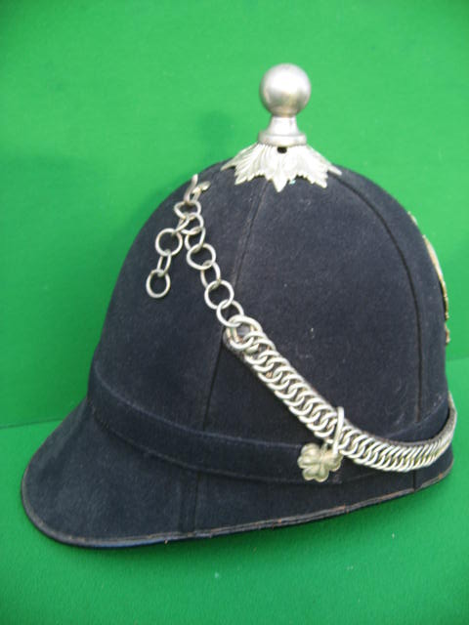
I suggest that by the mid 1920’s any existing D.M.P helmets still in stock in the Garda Depot had been exhausted and new four panel helmets were supplied by John Ireland of Ellis’s Quay Dublin. Only two suppliers of four panel helmets are known Hobson and Sons of London and John Ireland of Ellis’s Quay Dublin. Small square paper labels with the name and address of Hobson and Ireland are to be found on the inside of most four panel Garda ball top helmets.
Opposite left is the side view of the first pattern four panel Garda Day helmet, with ball top, chain and shamrock bosses for securing the white metal chain.
The next major change came in the 1940’s with the introduction of the Garda six panel blue cloth helmets. These helmets had a green internal liner and were very similar to the Bobby style helmets in the U.K. Once again, the same Garda helmet plate was used i.e. 7cms X 7cms. It must be noted however that at a later stage the commonly referred to Garda “motorcycle helmet plate” was also worn on the six panel Garda rose top helmet. While many collectors claim that this was never the case, there is photographic evidence proving that motor cycle helmets were worn on six panel helmets. 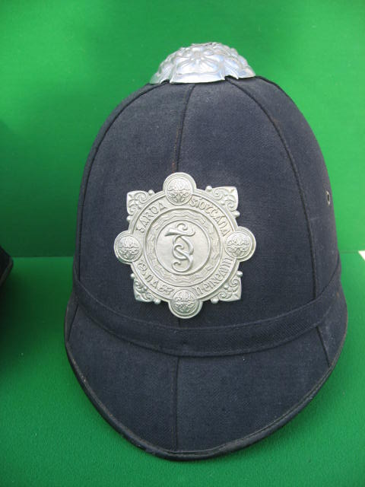
Garda six panel helmet, with rose top. This example has an internal issue date for Oct 1947.
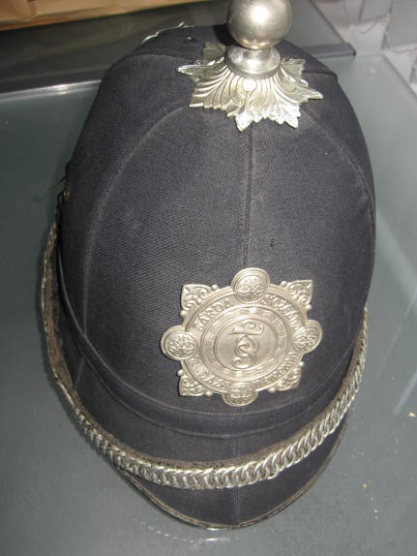
Six panel helmets had a rose top. Such helmets never had a ball top! However it must be noted that many examples of six panel helmets are in existence with ball top fixings. While the fittings and helmets are all original D.M.P./Garda items, these helmets are composite pieces and were never officially worn by the Gardaí. The composite six panel Garda ball top helmets came onto the market in the twentieth century when the theatrical suppliers began to sell some of their stock. These helmets though original, had been adapted for film and stage. You may notice that many of these composite helmets have the remains of silver paint on the front leather peak. Without doubt these helmets were designed to replicate D.M.P helmets for drama/theatrical purposes.

Opposite is a Garda six panel composite helmet, the chain, shamrocks and ball top are original D.M.P. but have been added to an original Garda six panel helmet from the 1940’s. The rose top has been removed. You will also note small traces of silver paint on the otherwise black leather peak.
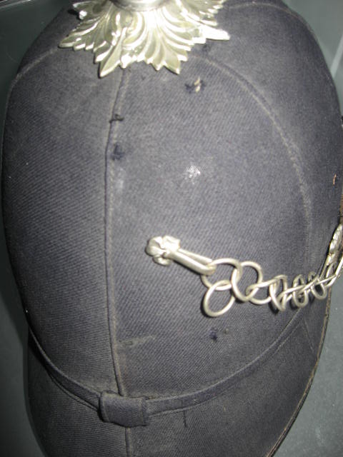
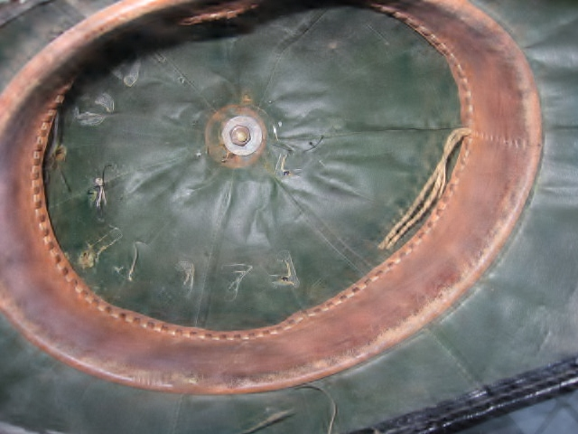The picture on left shows the six panel helmet with a small shamrock which was used to hang the chain. However, white metal chains were only used on D.M.P. and Garda four panel helmets. White metal chains were never worn on six panel helmets. By the 1940’s the chain had been replaced by a leather chin strap
Above right is a view of a composite six panel helmet from top looking down on the D.M.P. ball top fitting. Note how internally the ball top has been secured rather crudely by a washer and nut. You also see the faint outline of an original Garda service number.
Below is the proper style of wheeled disk device used to secure the white metal ball top to the four panelled helmet. The paper supplier label reads “J. IRELAND & SON, ELLIS’S QUAY DUBLINW6” The brass split pin is used to secure the little white metal shamrock to the back of helmet. 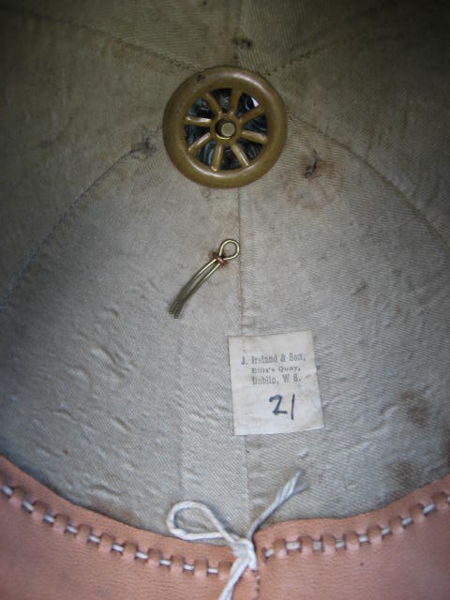
The Garda Night helmet.
The use of Day and Night helmets in the history of Irish policing have their origins in pre Independence policing forces, namely the Royal Irish Constabulary and the Dublin Metropolitan Police. During the short lived era of the Póiliní Átha Cliath (1922 -1925) these Dublin Policemen had a darkened brass helmet plate identical in design to the Day plate on the Póiliní helmet illustrated at the start of this article – except of course the night plate was darkened brass. The basic difference between Day and Night helmet plates is one of colour. The die struck Garda night helmet is identical to the Day helmet and most likely stamped from the same dies. The only difference is while the Day helmet was struck from white metal the night helmet is designed from blackened brass. 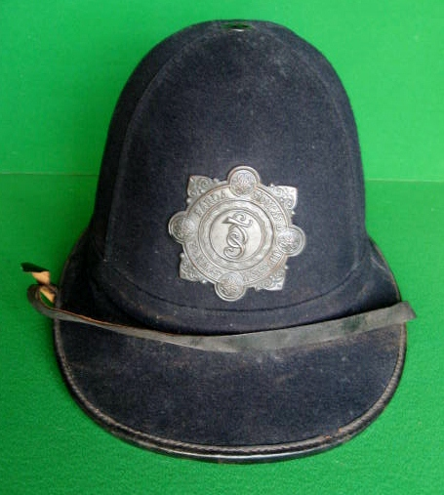 Garda Night Helmet viewed from front with darkened brass helmet plate.
The shape of the night helmet remained basically the same with the same design continuing from the late Victorian era right through to the 1950’s. For want of a better description, collectors have affectionately referred to the Garda night helmet as resembling “something from the Key Stone cops”
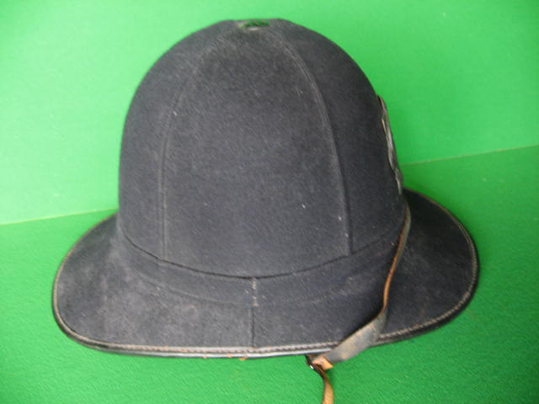Garda Night helmet viewed from the side. Note these helmets were four panelled with cork covered blue cloth.

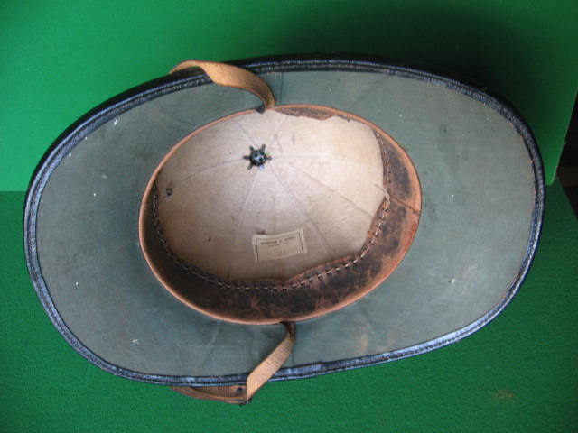Night helmet interior, with creamy canvas lining on the skull, green lining on the brim and finished with a stitched black leather trim to rim (cont’d on next page.)
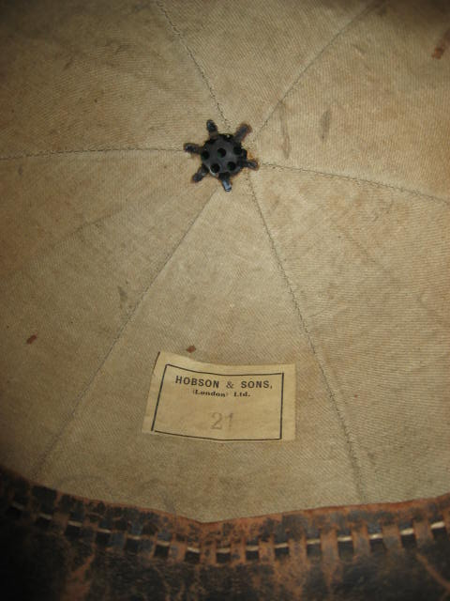The interior of this Garda Night helmet has a supplier’s paper label “Hobson & Sons (London) Ltd.” 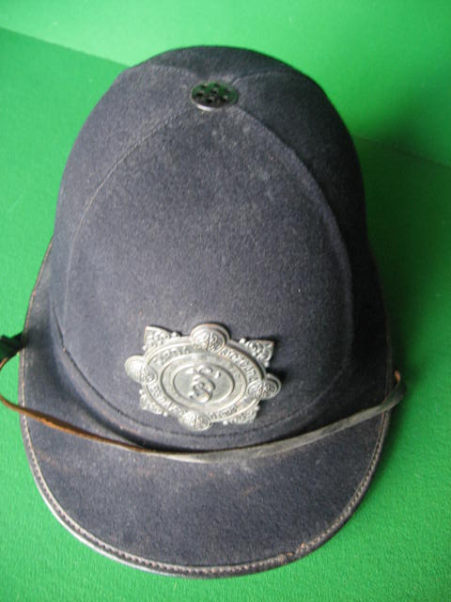
Similar to the Night helmet illustrated above, air was allowed to circulate via a small round vent on the top of the helmet. Garda night helmets never carried additional furniture such as ball tops, shamrock bosses or metal chains. All Garda night helmets had a simple leather chinstrap.

End.
Copyright: Austin Fennessy 2012. No part of this article may in anyway be copied without the prior permission of the author.

